**High-fidelity mockup**

* **Challenge type: Introduction, consolidation in group**
* **Duration: Entire day**
* **Deadline**: End of the day
* **Team challenge** : Groups

# Objective

The next step before starting the final design of a website is the graphic design. For this we will work today on the high-fidelity mockup.

# Definition

A high-fidelity mock-up is a fully realized representation of the final website design, including all design elements such as colors, typography, images, and icons. It is visually polished and demonstrates the look and feel of the final product. High-fidelity mock-ups are used to get final approval from clients or stakeholders and serve as a guide for developers during the coding phase.

**Graphic design**: “the art and practice of planning and projecting ideas and experiences using visual and textual content”. For the web, it is simply the arrangement of drawings, texts, images to communicate via a web page.

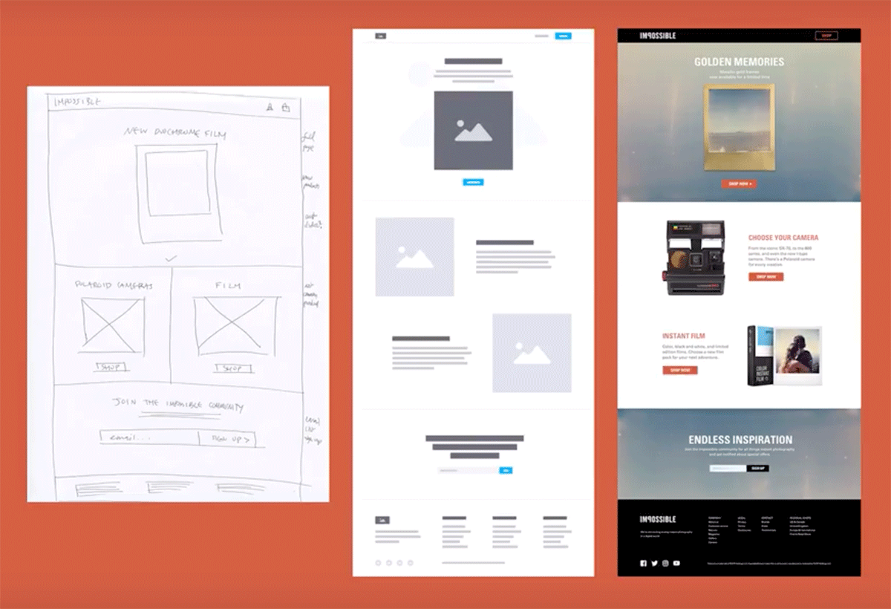

The example above shows the wireframe, mockup and final design phases.

# Exercise

The goal is to continue working on the design of the website you have selected

1. Take your low-fidelity mock-up back to Figma.
2. From there, implement the images, any drawings, the text, the logo respecting your original example.
3. To help you, reuse your components (for example for the header or footer) so as not to re-invent the wheel.

# Pedagogical objectives

* Explore the conception of the design of a website.
* Use Figma.
* Work as a team on the same tool.